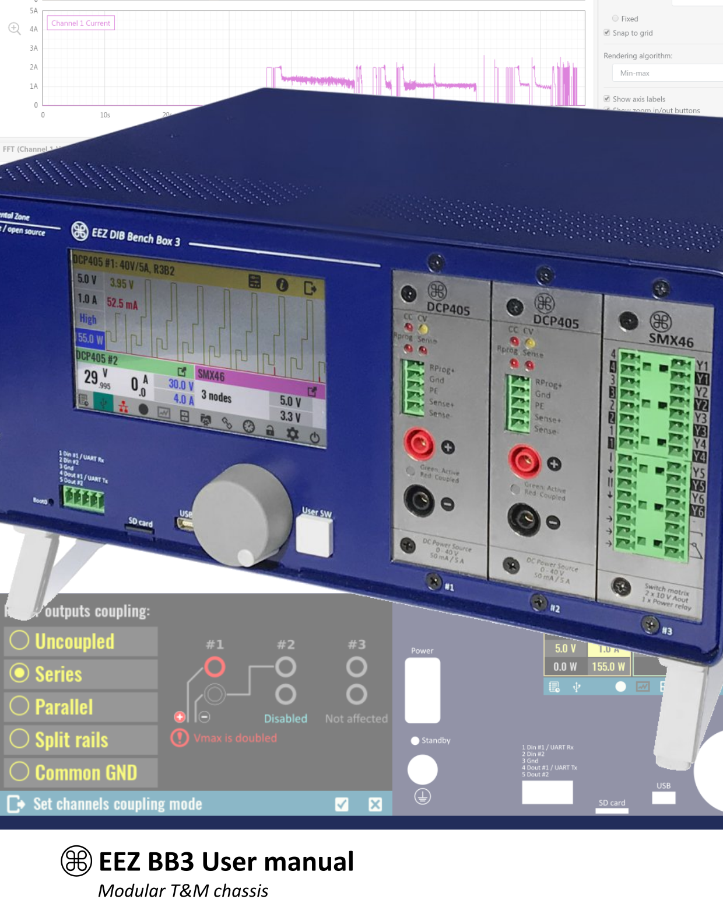
Ver. 1.08 – 09/2021
www.envox.eu – github.com/eez-open

